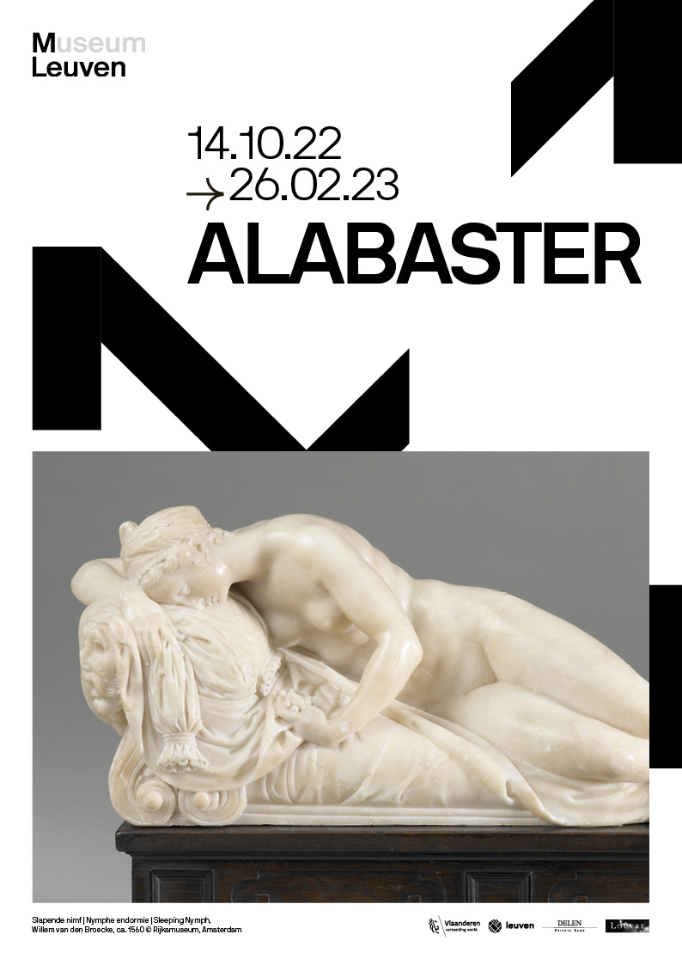
SCULPTING IN ALABASTER

If parsnips and warmoes are vegetables of yesteryears then alabaster is a stone of yesteryears – forgotten by the general public. Unlike, for example, marble or granite, today alabaster is only rarely used as a material in art. But you probably best know this stone from another context: anyone in Belgium who has been married for 75 years celebrate their so-called alabaster wedding. This means that alabaster is rated higher than ruby (40 years), gold (50 years) or diamond (60 years), to name but a few. How come we attach so much value to a stone that is so unknown?
The use of alabaster dates back to the ancient Egyptians. The name of the stone is said to derive from the Egyptian region of Alabastron, and the vases known as Alabastron vases. But the spread and popularisation of alabaster across Europe did not occur until the late Middle Ages. European alabaster, which has a different composition than the antique variant, is very soft and therefore easy to work with, so it quickly became a popular material in sculpture. Alabaster was valued as a luxury stone par excellence and the ideal alternative to Italian marble which it closely resembles.
In this exhibition, the material and symbolic aspects of alabaster are explained with the help of masterpieces from the 14th to the 17th century: from Gothic retable fragments to Baroque altars and from tiny collector's items to monumental tombs. The first room provides an overview of the characteristics that have made alabaster such a popular material. Its skin-like shine, transparency and the colour of the stone.
But the story of alabaster does not end with the 17th century. That is why this exhibition also contains contemporary works by the Belgian artist Sofie Muller (b. 1974). Alabaster’s materiality is central in her practice with the roughness of the newly quarried tuber of alabaster contrasting the velvety softness and beauty of the polished end product. This way, Muller uses alabaster to analyse and represent mankind in a psychological manner.

Trustees: Marjan Debaene (M Leuven) and Sophie Jugie (Louvre Museum)
This exhibition is presented with the exceptional collaboration of the musée du Louvre. The exhibition is co-sponsored by the Flemish Community, Bank Delen and M-LIFE.

RESEARCH

The exhibition can rely on the latest research findings from a number of projects around alabaster. This material is one of the newcomers in the so-called 'material turn' that has taken place in recent years, with a greater focus on multidisciplinary and material-technical academic research, complementing the mainly monographic-stylistic, iconographic and typological research that has dominated art history since the 19th century.
Isotopic analysis
The Sculpture Department of musée du Louvre, in collaboration with several French scientific institutes (Laboratoire de Recherche des Monuments Historiques, Bureau de Recherches Géologiques et Minières, and Centre Interdisciplinaire de Conservation et de Restauration du Patrimoine), is conducting a multidisciplinary research programme based on isotope analysis. These analyses allow the precise provenance of alabaster to be determined, often down to the level of the specific alabaster quarry. This information is compared with data on the history of the quarries and trade flows, the main building sites and their patrons, which in turn may reveal a hitherto unknown history of the origins of alabaster found in France. There has in fact been quite a bit of confusion about the material alabaster. No one alabaster is the same; there is calcite alabaster and also gypsum/anhydrite alabaster. It is from the former, known as "Egyptian" or "Oriental" alabaster, that the materials gained their names. The stone used for Egyptian alabastra consists of the mineral calcite, is brownish and banded. 'Real' alabaster, which is the subject of the expo, was widely available but only used in medieval and early modern times in Western Europe; it is the noble variety of plaster.
A reliable analytical method was developed in France by the LRMH and the BRGM in 2014 on the basis of the isotopic composition of sulphur, oxygen and strontium, three elements found in alabaster. In fact, most chemical elements have several stable natural variants, called isotopes, because they are in the "same" (ίσος) "place" (τόπος) of the periodic table and differ only in their mass. The ratio of heavy to light isotopes of the different elements in a material provides a kind of "fingerprint". This new method allows researchers to distinguish the most important historical alabaster deposits in England, France, Spain, Italy and Germany.
Marble or Alabaster?
Alabaster or white marble, they are not always easy to tell apart. Visually, these two stone types can be very similar as both are white to beige in colour, translucent and can be finished to a certain sheen. This created confusion between the two stones (both visually and in terminology used) from as early as the Middle Ages. Chemically and mineralogically, however, the two types of stone have little or nothing in common. In terms of mineralogy, alabaster is a variant of the mineral gypsum or anhydrite (calcium sulphate), while metamorphic marble is composed of carbonate minerals, mainly calcite and dolomite. It is generally difficult to determine the source of the white translucent stone type unless some obvious features are present, such as veining. It is also often difficult to tell them apart given to the poor state the artwork or the presence of old surface treatments such as wax or oil.
The aim by the Royal Institute for Art Heritage’s (KIK-IRPA, Brussels) ongoing study is to distinguish the two materials using a non-invasive method, namely an XRF analysis. This has the advantage that no samples have to be taken from the artwork and the object is not damaged. Funded by the Professor Jean-Jacques Comhaire Fund of the King Baudouin Foundation, the project is being carried out by an interdisciplinary team from the KIK-IRPA. This research has already been able conclusively to prove that work such as 'Saint Catherine of Alexandria' by André Beauneveu was indeed made of alabaster, and not marble.
Grave sculpture
Safe in their Alabaster Chambers -
Untouched by Morning
And untouched by Noon -
Sleep the meek members of the Resurrection
[...]

So begins the poem 'Safe in their Alabaster Chambers' by 19th century poet Emily Dickinson. In the poem, the dead await the resurrection inside their alabaster chambers – a direct reference to the centuries-old tradition of using alabaster for funerary monuments and tombs.
The predilection for alabaster in grave sculpture is not surprising. Alabaster was a prestigious material that allowed patrons could flaunt their wealth and good taste even beyond death. Alabaster was also seen as the stone that resembles human skin the most and could thus symbolically bring the dead back to life.
The use of alabaster in funerary art started in the 14th century in the royal courts of England, France and Aragon and was subsequently adopted throughout Europe and among different sections of the population. There are even examples of complete tombs made of alabaster, from the architectural framework to the sculptural elements. But usually, several materials would be used together, with alabaster being reserved for the main components of the monument such as the statue of the deceased or other human figures.
Working in alabaster on such a large scale was not easy. Unlike marble, alabaster is mined in relatively small nodules. For large-scale works, therefore, either an exceptionally large segment had to be discovered, or several smaller pieces had to be put together. For large-scale works, it was necessary either to find an exceptionally large block, or to use large benches such as those found in the Alps, or to assemble several fragments. The large recumbents and kneeling statues bear witness to the efforts that some people had to make to be immortalised in alabaster.

Altarpieces and reliefs: 14th-15th century
During the Middle Ages, the altar of a church or chapel was not complete without an accompanying altarpiece or retable, the origin of which lies in the placing of relics or saints on the altar for veneration. These retables could be a painting, but sculpted ensembles were often preferred. In the course of the 14th century, the royal court of France developed a preference for altarpieces in white stone – marble or alabaster – against a dark background. Following France's example, an affection for alabaster altarpieces and reliefs developed in other regions of Europe too.
In particular, a rich production of altarpieces in alabaster was seen in England. In the Nottingham area, where there were seemingly inexhaustible alabaster quarries, standardised but high-quality alabaster altarpieces were produced – an early form of mass production. The altarpieces were sold on the local market, but were also exported abroad to Italy and Spain.
On the European mainland workshops specialised in alabaster altarpieces appeared, but these were few and far between. The best-known example is the studio of the so-called Master of Rimini from the first half of the 15th century – a sculptor whose name we do not know with certainty, and who is therefore named after his main work: the 'Crucifixion Retable' from the Santa Maria della Grazie church in Rimini, Italy and now on display in Frankfurt. In his workshop, this artist, who may have been from Bruges, produced extraordinary alabaster figures and reliefs which were appreciated all over Europe.
The production of alabaster altarpieces in the Low Countries came to a virtual standstill in the second half of the 15th century. The Low Countries had always had a preference for polychromed wooden altarpieces, which on the European market were the strongest competitor for the alabaster altarpieces from Nottingham

Altarpieces and reliefs: 16th-17th century
From the early 16th century, the tide turned for alabaster altarpieces in Europe. The Renaissance brought with it a renewed interest in ancient art and alabaster gained a reputation as the Northern European equivalent of Italian marble.
Jean Mône, master craftsman of Emperor Charles V and regarded as the first Renaissance sculptor of the Low Countries, worked exclusively in alabaster. Both small reliefs and large-scale altarpieces are attributed to him. This immediately set the standard for the production of altarpieces in the Low Countries as Gothic wooden altarpieces went out of fashion and artists were increasingly focusing on alabaster altarpieces in the antique style. Mechelen in particular saw large numbers of alabaster reliefs produced, often intended as domestic altars for private use.
In other areas, too, alabaster was considered the ideal material for Renaissance sculpture, both on a large and small scale. In Spain, churches were given with immense altars, sometimes more than twelve metres high, with dozens of figurative reliefs in alabaster. In addition, renowned artists such as Diego de Siloé or Damiàn Forment also worked on small-scale, refined reliefs for chapels or private devotion. In France, not by coincidence in the immediate vicinity of Paris and the royal court – where the preference for alabaster had its origin two centuries earlier – churches were richly decorated with alabaster altarpieces. Evidence of this is the imposing relief with the 'Death of Mary', which was probably part of an even larger ensemble.
For princes and collectors
Although the private art collection has now become an integral part of the cultural landscape, collecting art in the modern sense of the word was not common during the Middle Ages. Art was traditionally intended for public institutions such as churches, palaces and monasteries or for personal devotion. But from the 16th century onwards and under the influence of the ideas of the Renaissance and humanism, the handling of art objects changed. Suddenly, every self-respecting humanist or well-to-do citizen wanted to use an art collection to show that they were up to date with new trends.
These early art collectors were very fond of Alabaster objects. Although it was less exclusive than ivory, alabaster had a value almost equal to that of marble. The way in which alabaster usually was quarried in small pieces mined along with the fine finish that the stone's softness allowed made it the ideal material for minute, virtuoso objects.
In addition to the religious sculptures already used in a private context during the Middle Ages, from the 16th century onwards more diverse objects were produced for the private market. Portraits, medallions, mugs, memorabilia and even glorified utensils in alabaster were indispensable in any art collection.
The 'Man of Sorrows' is a great example that alabaster sculptures remained very popular among collectors also after the 16th century. This virtuoso piece was perhaps the favourite object of Fritz Mayer van den Bergh, whose personal collection formed the basis of the museum of the same name in Antwerp.
Alabaster from the Celestine Church of Heverlee
When in 1521 William of Croÿ, councillor to Emperor Charles V and owner of Arenberg Castle in Heverlee, felt his death approaching, he expressed in his will his wish to build a monastery as a mausoleum for himself and his descendants. Shortly after his death, his widow, Maria van Hamal, arranged for the construction of what was to become the Celestine Priory of Heverlee to start: a spacious monastery with an attached convent church. As the church was the burial place of the noble family of Croÿ it had to reflect the fame and wealth of the family in every way. No expense was spared when decorating the church and the Celestine Priory soon was flowing over with Renaissance art of which the alabaster sacrament tower, tombs and altarpieces were the artistic highlights.
For centuries, the Celestine Church was considered one of the most valuable religious buildings in the Low Countries. However, this reputation could not save the church from the disasters of the French Revolution. In 1796, a troop of Leuven revolutionaries marched to the monastery, led by a certain Red Max. They broke down the door and destroyed just about everything they came across. The church was left disfigured, and in 1816 the decision was made to demolish it altogether. Some parts of the monastery remained in use and in 2000 were revived as the 2Bergen Campus Arenberg library.
A few of the remaining sculptures from the former church have been brought together in the last room with the gigantic 17th-century St Anne altarpiece by Robrecht Colyns de Nole as the focal point – a last highlight of alabaster alterpiece sculpture. By using the touch screen, you can gain an impression of what the church would have looked like in its heyday, a lost gem of architecture and alabaster sculpture.

HIGHLIGHTS
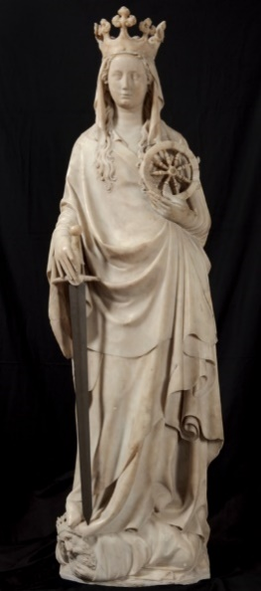  1. Andre Beauneveu, St Catherine of Alexandria,  1374–84, alabaster  Onze-Lieve-Vrouwekerk, Kortrijk  © KIK-IRPA Brussels | 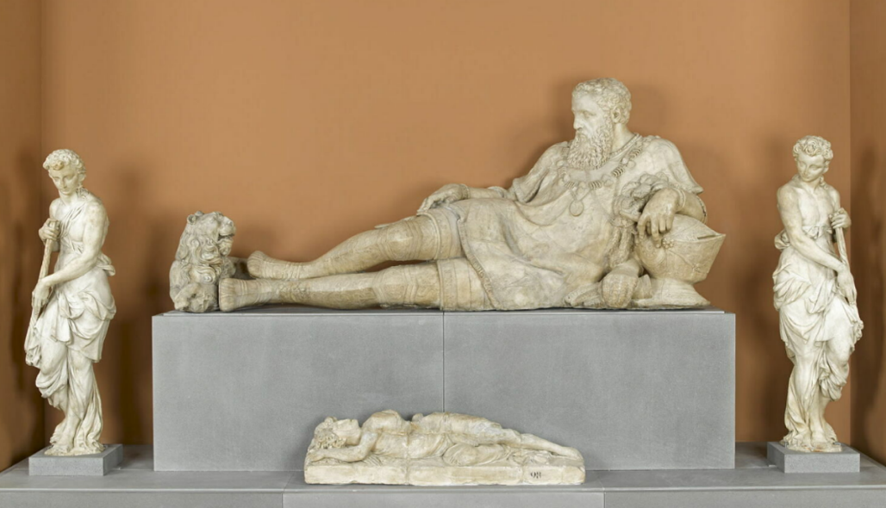  2. After a model by and under the supervision of Jean Cousin, Tomb of Philippe Chabot,  between 1543 and 1570, alabaster  Musée du Louvre, Paris  © RMN-Grand Palais (musée du Louvre) / Stephane Marechalle
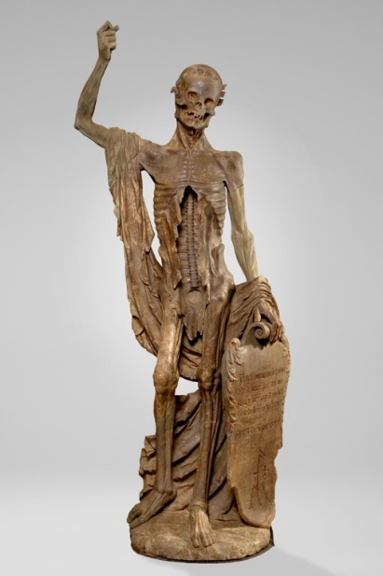  3. Ile-de-France, Allegory of Death (‘La Mort Saint-Innocent’),  ca. 1530, alabaster,  Musée du Louvre, Paris  © RMN-Grand Palais (musée du Louvre) / Pierre Philibert | 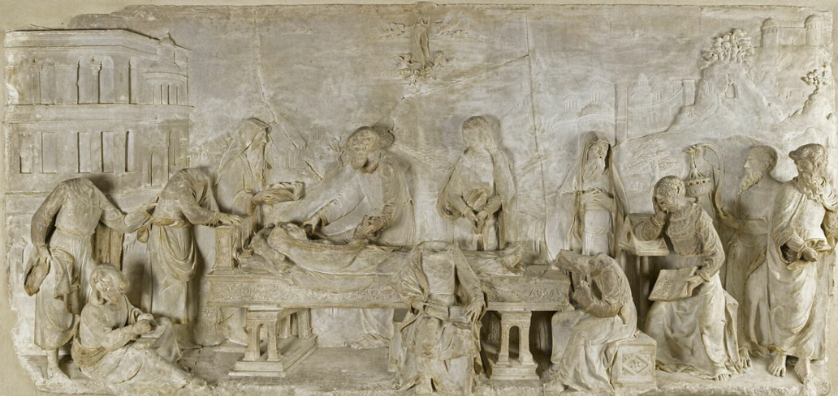  4. Attributed to Giovanni di Giusto di Betti (known as Jean Juste),  The Death of the Virgin  ca.1530-40, alabaster  Musée du Louvre, Paris  © RMN-Grand Palais (musée du Louvre) / Mathieu Rabeau

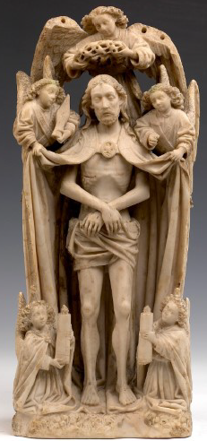  5. Southern Netherlands, Man of Sorrows,  ca. 1460-70, alabaster,  Museum Mayer van den Bergh, Antwerp,  © Photo: Hugo Maertens | 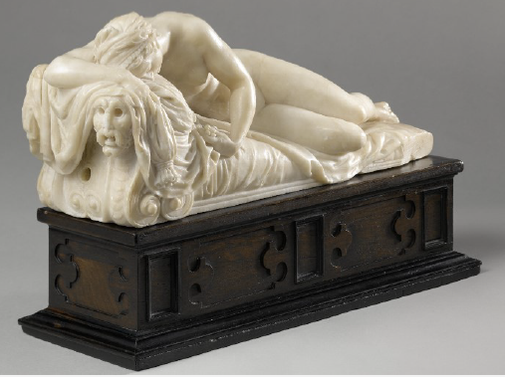  6. Attributed to Willem van den Broecke  (‘Guglielmus Paludanus’), Sleeping Nymph,  1555-60, Alabaster  Rijksmuseum, Amsterdam  © Rijksmuseum Amsterdam

FAMILY OFFER

Red Dog: Experiencing 'Alabaster’ with Klankennest
The festival runs from 03.11.22 - 06.11.22
Museum tours on:

- 03.11.22 | 11.00 - 12.00 and 15.30 - 16.30
- 04.11.22 | 11.00 - 12.00 and 15.30 - 16.30

Activities for young and old are organised at various locations in Leuven during the really fun arts festival Red Dog. And yes, M, too, is back on the scene! Together with your baby, toddler or nursery child, this tour lets you discover the museum in a playful and creative way. Two actors lead you through the new Alabaster exhibition. Expect a sensory experience in sound and image for adults and the very youngest among us!

For babies, toddlers and nursery children (0 to 4 years) and their parents - In duo: 1 parent, 1 child
Price: €8/per person (discount UITpas 80%)
Registration is mandatory: mleuven.be

Red Dog: 'Alabaster' family tour

The festival runs from 03.11.22 - 06.11.22
Tours:

- 04.11.22 | 11.30 - 12.30 and 15.00 - 16.00
- 05.11.22 | 11.30 - 12.30 and 15.00 - 16.00

Special materials, techniques, colour, light and lots of stones. That is what you can expect from the Alabaster exhibition. Alabaster is a white stone which sometimes is reminiscent of marble but it is much softer. It was used for many different types of objects and certainly also works of art. Explore with your family on this interactive tour tailored for nursery children. A guide will take you through some highlights of the exhibition for an hour. Looking, imagining, dreaming and amazement: it all comes into play.

Families with children aged 3 to 6
Price: €5/ per person (discount UITpas 80%)
Registration is mandatory: mleuven.be

Children's art day: 'Alabaster' family workshop: getting started as a sculptor
20.11.22 | 14.00 - 16.30
Special materials, techniques, colour, light and lots of stones. That is what you can expect from the Alabaster exhibition. Alabaster is a white stone which sometimes is reminiscent of marble but it is much softer. It was used for many different types of objects and certainly also works of art. This workshop will help you transform into a real sculptor. Loes and Inez from Atelier Kastart first take you through the Alabaster exhibition. Then the workshop continues in the studio where you get to fully indulge yourself as a real sculptor.

Families with children aged 6 to 10
Price: €5/ per person (discount UITpas 80%)
Registration is mandatory: mleuven.be

Seniors' month: Walking through 'Alabaster'

26.11.22 | 13.00 - 14.30 and 15.00 - 16.30
A guide will take you through the new 'Alabaster' exhibition. Using the stories of the artworks, you will reminisce and converse. Engage with the guide, the other participants and the artwork during this special walk through M.

Price seniors: €5/per persoon
Inschrijven is verplicht: mleuven.be

Family course ‘Alabaster’
14.10.22 - 26.02.23 | opening hours museum
If parsnips and turnips are forgotten vegetables, alabaster is a forgotten stone. The material was more luxurious than gold and soft as velvet. It was in the Middle Ages one of the most popular materials within sculpture. This family tour will acquaint you with this equipment inside and out! Fairy-tale statues, giant tombstones and tiny collectibles take you on a journey of discovery!

Families with children aged 8 to 12
Price: free with valid admission ticket
PUBLICATION
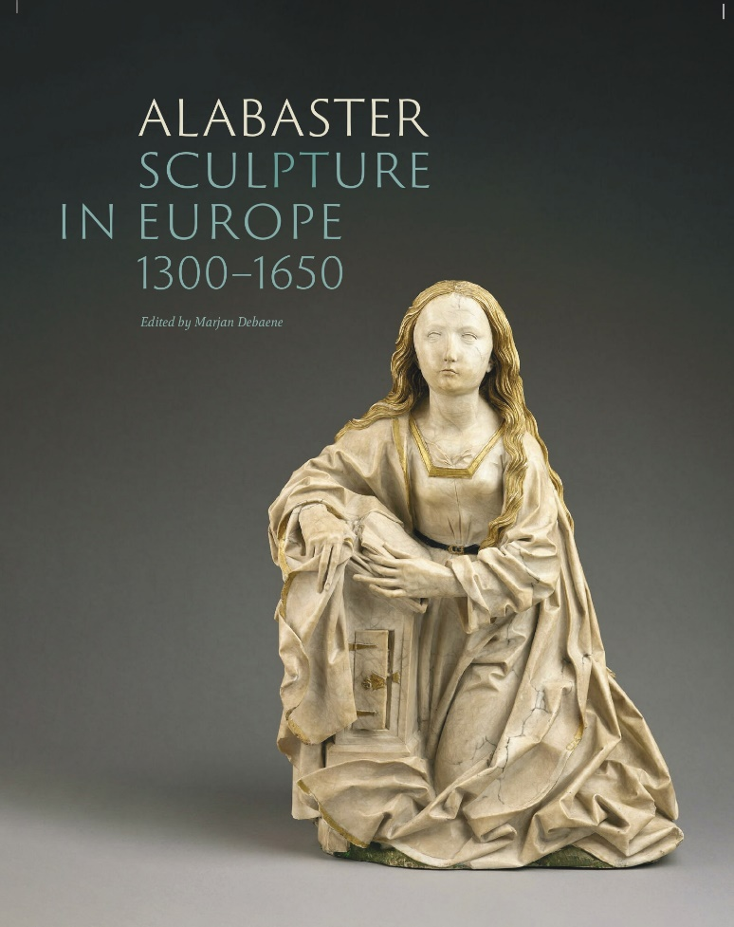
Alabaster sculpture in Europe 1300-1650
From England, Spain, and France, to the Low Countries, Germany, and Poland, alabaster was a popular material in European sculpture, in particular between the fourteenth and seventeenth centuries. More readily available than marble in most countries north of the Alps and easier to carve, this soft and fragile stone was suitable not only for bespoke monuments and altarpieces, but also for statuettes and reliefs produced for the open market. For several decades alabaster has been the subject of multidisciplinary research combining technical analysis with historical and art-historical approaches. This book, published on the occasion of the major exhibition of alabaster sculpture at M Leuven from October 2022 to February 2023, brings together the field's most renowned specialists. It sheds light on the many facets of alabaster, including its physical and chemical properties, its translucency, whiteness, softness, and beautiful sheen, which were exploited to advantage throughout Europe from the late Middle Ages to the Baroque era in a variety of sculptural types and genres, of religious and secular subjects alike.

Technical details:
- Publisher(s): Harvey Miller Publishers (Brepols Publishers)
- Graphic design and typesetting: Paul van Calster, with Anne Luyckx, Anagram (Ghent)
- Translation: (From the French) Caroline Beamish, (from the Spanish) Donald Pistolesi, (from the Dutch) Lee Preedy, (from the German) Karen Williams
- Final editing: Edited by Marjan Debaene
- With essays by Jessica Barker, Marjan Debaene, Lloyd de Beer, Judy De Roy, Laurent Fontaine, Sophie Jugie, Wolfram Kloppmann, Aleksandra Lipinska, Carmen Morte García, Sofie Muller, Géraldine Patigny, Stefan Roller, Soetkin Vanhauwaert and Michaela Zöschg
- ISBN: 9781912554935
- Dimensions in cm: 30 cm (H) x 24 cm (W) x 2 cm (D)
- Number of pages: 312 pages
- Cover: soft
- Price: 50 euros (in the M bookshop)
- Languages: English

PRACTICAL
M LEUVEN
Vanderkelenstraat 28
3000 Leuven
+32 (16) 27 29 29
info@mleuven.be
www.mleuven.be
Plan your route to the museum
By bicycle
All cyclists are welcome. The easiest and safest place to leave your bicycle is in the bicycle parking under Rector de Somerplein. From there, it is a two-minute walk to the museum.

By public transport
The museum is a ten-minute walk from Leuven station. If you come by bus, Rector de Somerplein is the nearest stop. Plot your route with Google Maps.

By car
The new circulation plan will lead you to Leuven and the car parks via several loops. Prefer to avoid city traffic? Then why not park your car in one of the peripheral car parks and take a free bus to the city centre. Prefer to park close by? Then there is parking Ladeuze which is a two-minute walk from the museum. There are also find 18 spaces for people with disabilities there (height parking: 1.90 m). Click here for more information on the circulation plan and all parking options.

CONTACT
Hanne Grégoire
Head of Department Communications
& Press
hanne.gregoire@mleuven.be
+32 (0)472 95 52 26
Samantha Fadahunsi
Communications & Press Officer
samantha.fadahunsi@mleuven.be
+32 (0) 491 35 02 95
Link web page:
https://www.mleuven.be/en/programme/alabaster
Link Prezly:
High-resolution images can be downloaded at the bottom of this press page
https://mleuven.prezly.com/media

